**COSC422 Assignment 1 Report**

**The Scene**

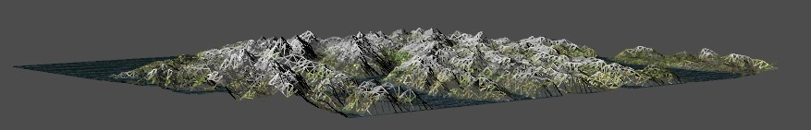

Figure 1 - Scene movement, Less Tessellation Levels (Blocky).

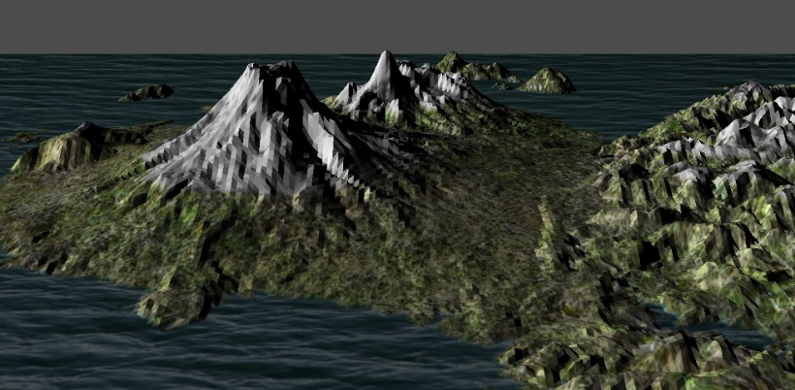

Figure 6 - Scene 2

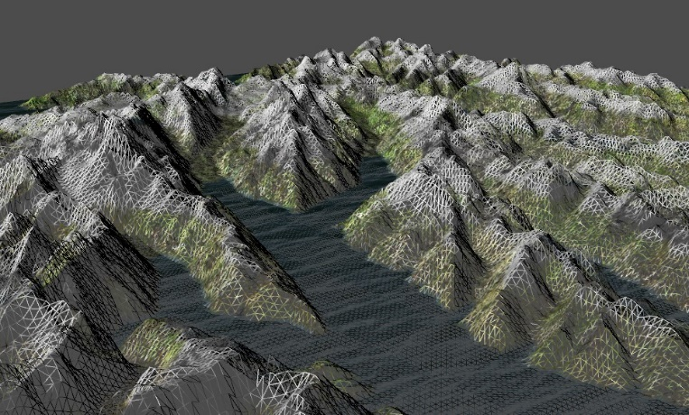

Figure 2 - Scene movement, More Tessellation Levels (Detailed).

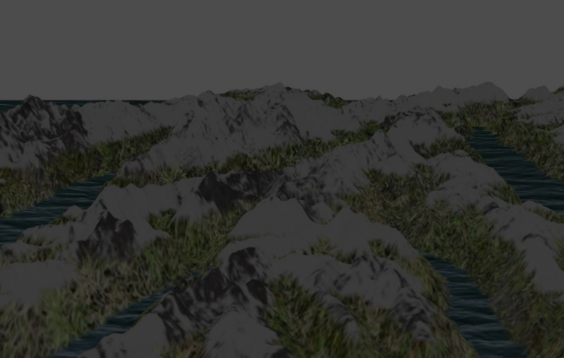

Figure 3 - Ambient Lighting

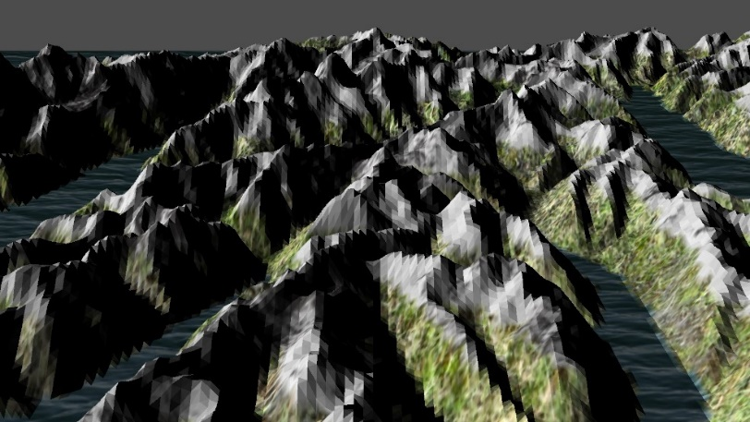

Figure 4 - Ambient + Diffuse Lighting

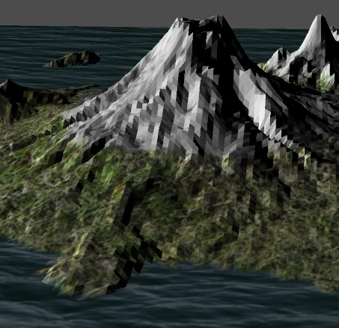

Figure 5 - Blending

Figure 8 - Cracking Fix, white background

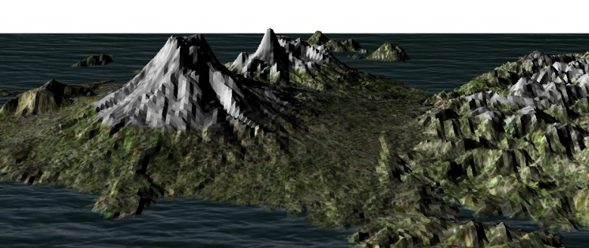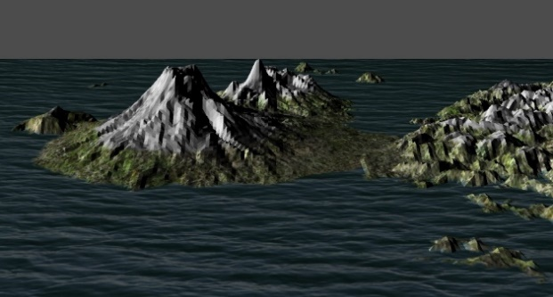

Figure 9 - Adjustable Water level

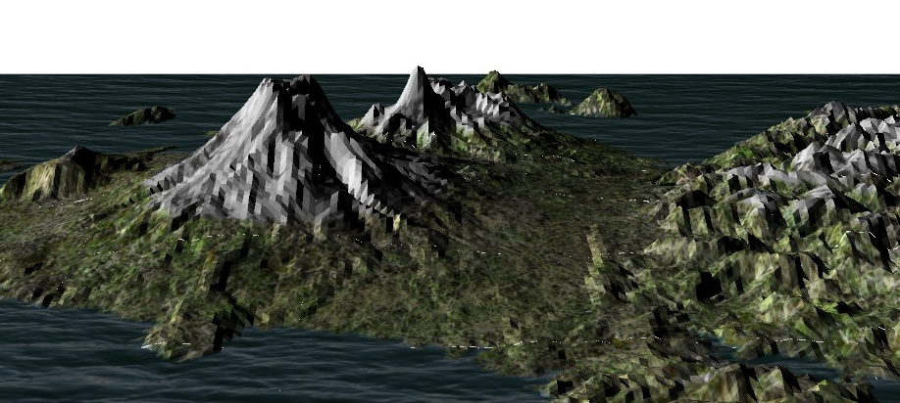

Figure 7 - Cracking Issue, white background

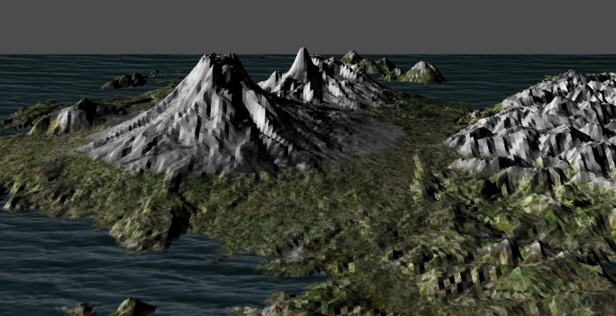

Figure 10 - Adjustable Snow level

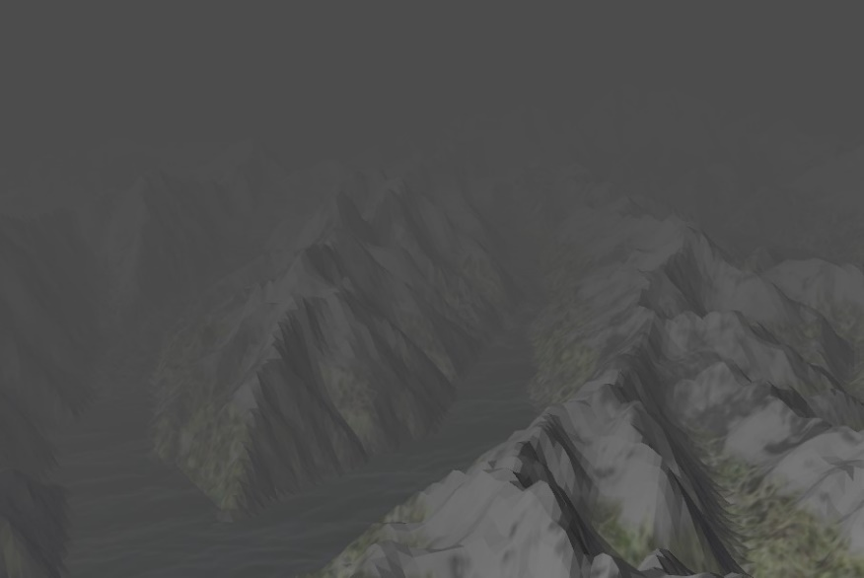

Figure 11 - Fog

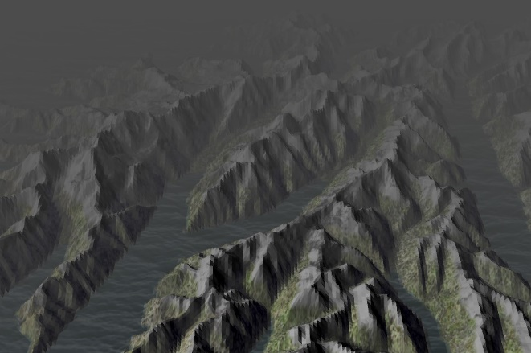

Figure 13 – Camera height

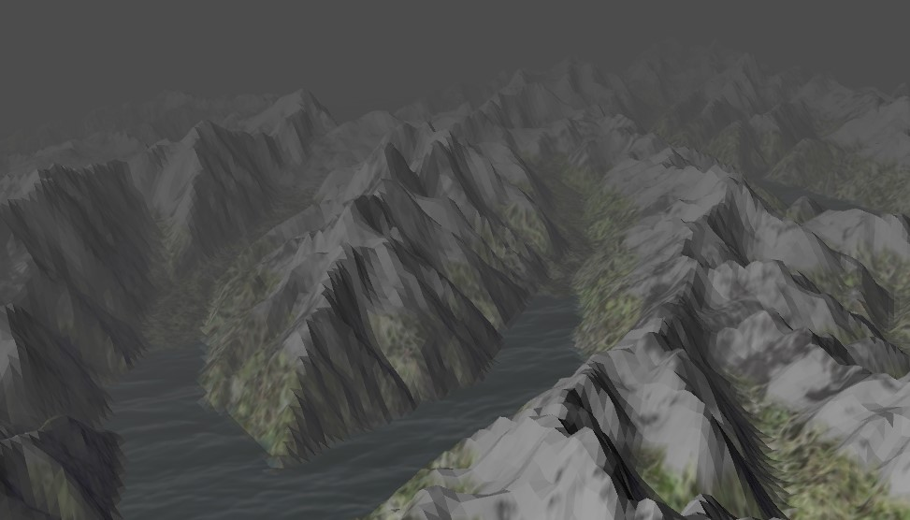

Figure 12 - Adjustable Fog density level

|  |
| --- |
| ↑ |
| ↓ |
| ← |
| → |

**Basic Terrain Model**

1. **Dynamic level of detail – Camera:**

Move around the scene via keystrokes.

Figure, 1 & 2 demonstrate how the Tessellation level changes. This can be seen when the camera actively moves around/over the scene (The Tessellation level is controlled by the Control shader). The scaling of the Height maps is done in the Evaluation shader. Spacebar Toggles the model from solid fill to wireframe & vice versa.

1. **Lighting:** This is computed in the Geometric shader. Figure 3 shows only ambient lighting and Figure 4 shows ambient + diffuse lighting. The diffuse lighting term was found via finding the Face normals of each sub patch dotted by the light pos.

The Fragment output color is then outputted in the Fragment shader. Toggle ‘l’ shows the difference.

1. **Text

   Description automatically generated****Textures:** Three additional textures were used, Water, Snow, and Grass. Figure 5 shows appropriate blending of textures, this was done by applying a weight to each texture in the Geometry. The weight was then timesed by the color of each texture in the Fragment shader. Texture mapping was done by,
2. A picture containing text, gauge, device

   Description automatically generated**Terrain Models:** Two Height maps are used, MtCook and MtRuapehu. Pressing ‘1’ loads MtCook and pressing ‘2’ loads MtRuapehu. Figure 4 and 6 show this.

**Extra features**

1. **Cracking:** This was solved by computing for the length instead of the distance.



This can be seen in Figure 7 and 8. Toggling ‘c’ toggles cracking and toggling ‘b’ changes the sky color from grey to white and vice versa.

1. **Adjustable water levels:** Adjusting water level can be seen in Figure 9, compare with Figure 6 to see the difference. ‘q’ Increases and ‘a’ decreases the level.
2. **Adjustable snow levels:** Adjusting snow level can be seen in Figure 10, compare with Figure 6 to see the difference. ‘w’ Increases and ‘s’ decreases the level.
3. **Fog:** Toggling ‘f’ for fog. Figure 11 shows this. In the Geometry shader a exponentiol is used softly fade the object in the distance. This is also clamped. The visibility color is then mixed with the sky color and other textures.



1. **Adjustable Fog:** Adjusting snow level can be seen in Figure 12, compare with Figure 11 to see the difference. ‘e’ Increases and ‘d’ decreases the density level.
2. Text

   Description automatically generated**Smooth Shadding attempt:** This was attempted in the Fragment shader to find the Vertex normals instead of the face normals.
3. **Extra Buttons:** Figure 13 shows lowering the height of the camera via ‘+’ or ‘=’ and increasing the height by ‘-’.

**Control Functions**

|  |  |
| --- | --- |
| ↑  Move forwards | 'q'  Increases water level |
| ↓  Move backwards. | 'a'  Decreases water level |
| ←  Turn left. | 'w'  Increases snow level |
| →  Turn right. | 's'  Decreases  snow level |
| Spacebar  Toggles between wireframe and textured view. | 'f'  Toggle fog |
| '1'  Displays Height Map 1 | 'd'  Decreases fog density |
| '2'  Displays Height Map 2 | 'e'  Increases fog density |
| '+' or '='  Decreases the cameras height | 'l'  Toggle light shading |
| '-'  Increases the cameras height | 'b'  Toggle sky color |
| 'c'  Toggle cracking |  |

**Compiling & Running Application**

On a Windows Machine, on the Makefile level, type: ‘make && make program’

**References to Sources**

* Height Maps from the lab.
* All mesh models from <https://www.textures.com/library>
* JPG to TGA converter <https://www.freeconvert.com/jpg-to-tga>